

**REPORT ON FINANCIAL PERFORMANCE**

**FOR THE PERIOD 1 JANUARY – 30 SEPTEMBER 2024**

**Zagreb, November 2024**

**RESULTS OF THE GROUP**

**BREAKDOWN OF THE MOST SIGNIFICANT FINANCIAL INFORMATION OF hbor GROUP**

|  |  |  |  |
| --- | --- | --- | --- |
| -in millions of euros- | **2022** | **2023** | **30 September 2024** |
| **Total assets** | 3,857.0 | 4,021.5 | 4,021.0 |
| **Gross loans** | 3,703.4 | 4,077.6 | 3,999.0 |
| **Total equity** | 1,422.2 | 1,457.9 | 1,504.2 |
|  | **1 January – 30 September 2022** | **1 January – 30 September 2023** | **1 January – 30 September 2024** |
| **Total income** | 70.3 | 92.4 | 102.0 |
| **Total expense** | (51.1) | (41.6) | (58.3) |
| **Profit** | 19.2 | 50.8 | 43.7 |
| **Interest income calculated on the basis of effective interest rate method and income from cancellation of the subsidy deferral at the expense of HBOR’s operations** | 63.2 | 68.3 | 88.4 |
| **Interest expense** | (15.7) | (19.6) | (34.7) |
| **Net interest income** | 47.5 | 48.7 | 53.7 |

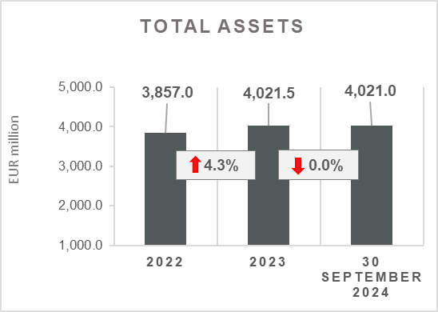 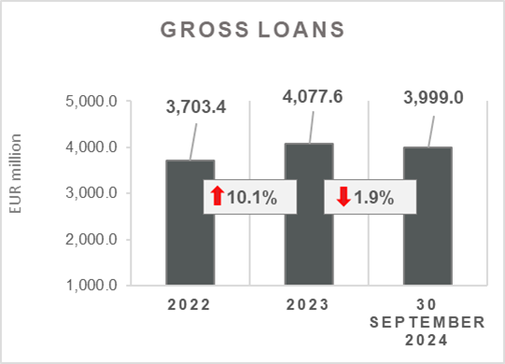

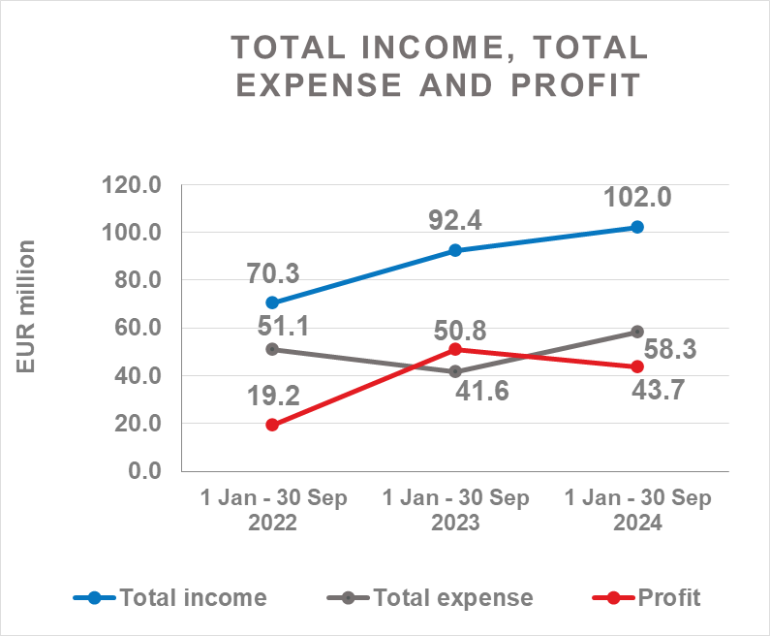 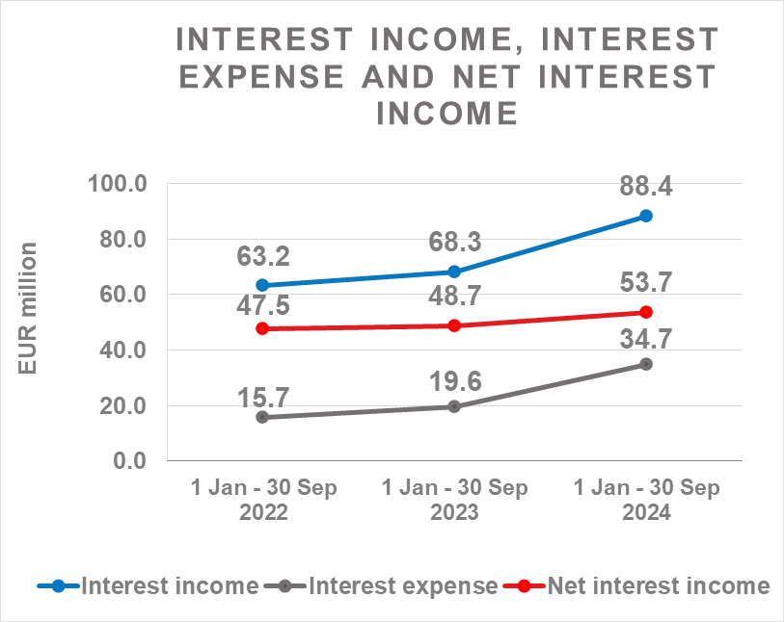

**Results of the Group**

In the period 1 January – 30 September 2024, the HBOR Group generated profit after tax in the amount of EUR 43.7 million.

Pursuant to the provisions of the Act on HBOR, the parent company is exempt from income tax and income tax liabilities arise exclusively from the activities of the other members of the Group.

In the period 1 January – 30 September 2024, total income on consolidated basis amounted to EUR 102.0 million, whereas total expenses amounted to EUR 58.3 million.

The consolidated total income increased by 10.4 percent, whereas total expenses increased by 40.1 percent compared to the same period previous year due to the developments in total income and expenses of the parent company.

In the structure of income of the Group, the largest portion, i.e. 86.3 percent, relates to interest income as a result of operations of the parent company.

The major part of total expenses, relates to interest expense (59.5 percent) and operating expenses (38.4 percent) arising from the operations of the parent company.

The consolidated operating expenses in the period 1 January – 30 September 2024 amounted to EUR 22.4 million and consisted of general and administrative expenses and other operating expenses.

On 30 September 2024, the Group had 456 employees (on 30 September 2023: 430 employees).

**Assets and liabilities of the Group**

Total assets of the Group on consolidated basis amount to EUR 4,021.0 million and were retained at the level from the beginning of the year.

In the structure of assets, the major portion relates to the lending activities of the parent company, i.e. net loans account for 87.8 percent of total assets.

Total liabilities and total equity as at 30 September 2024 amount to EUR 4,021.0 million, of which amount total liabilities equal EUR 2,516.8 million, i.e. 62.6 percent.

In total liabilities and total equity of the Group, the major portion, i.e. 54.6 percent, consists of borrowings of the parent company.

At the end of the reporting period, total equity on consolidated basis amounted to EUR 1,504.2 million and accounted for 37.4 percent of total liabilities and total equity of the Group.

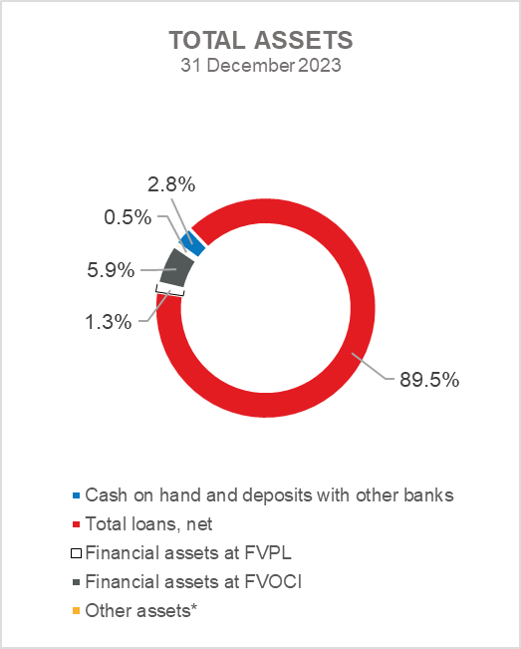 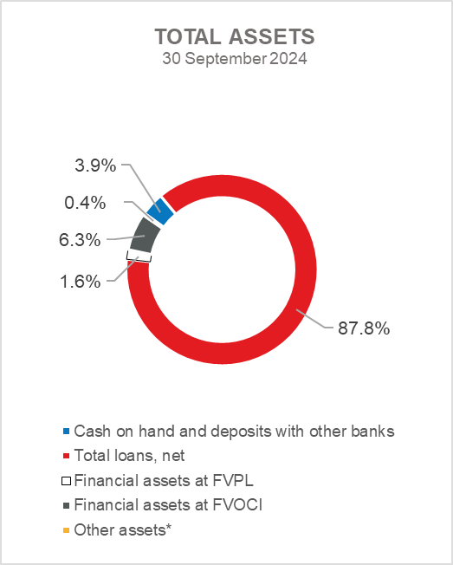

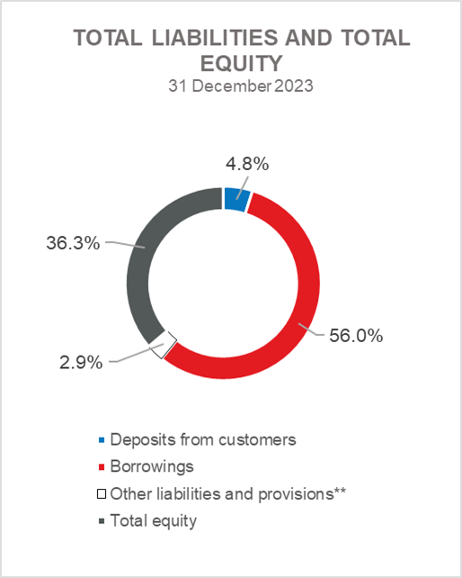 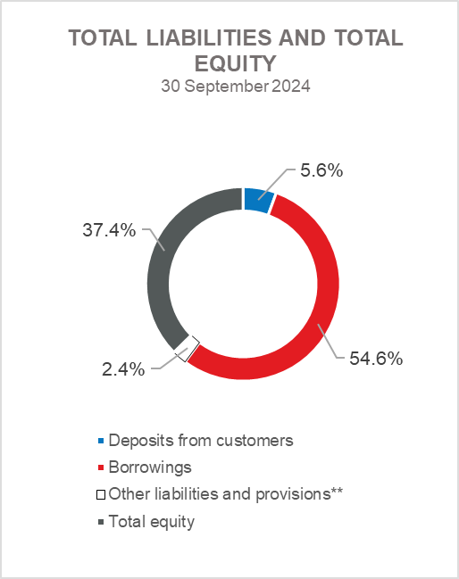

*Property, plant and equipment and intangible assets, Foreclosed assets, Debt securities at AC and Other assets.

**Provisioning includes provisioning for guarantees, commitments and other liabilities.

**RESULTS OF HBOR**

**OVERVIEW OF FINANCIAL PERFORMANCE OF HBOR**

The following text gives an overview and explanation of the significant changes in financial position and operating performance in the reporting period.

**Financial performance**

In the period from 1 January to 30 September 2024, HBOR generated total income of EUR 99.8 million, expenses of EUR 56.2 million and profit in the amount of EUR 43.6 million. HBOR’s profit generated in the reporting period decreased by EUR 6.8 million compared with the profit generated in the same period last year.

The decrease in profit in the period from 1 January to 30 September 2024 compared with the same period last year is a result of a larger increase in total expenses (by EUR 16.5 million) than an increase in total income (by EUR 9.7 million).

The circumstances that affected the financial result achieved in the nine-month reporting period 2024 compared to the results generated in the same period in 2023 are:

* increase in interest income of EUR 19.7 million,
* increase income from the cancellation of the subsidy deferral at the expense of HBOR's operations by EUR 0.4 million,
* increase in interest expenses of EUR 15.1 million,
* decrease in net income from fees and commissions of EUR 2.2 million,
* increase in net gains from financial activities in the amount of EUR 3.1 million,
* increase in other income of EUR 0.9 million,
* decrease in net impairment gains and provisions by EUR 10.5 million,
* increase in operating expenses of EUR 2.7 million,
* increase in subsidy cost at the expense of HBOR’s operations by EUR 0.4 million.

A detailed description of trends is given for each category separately in the following text.

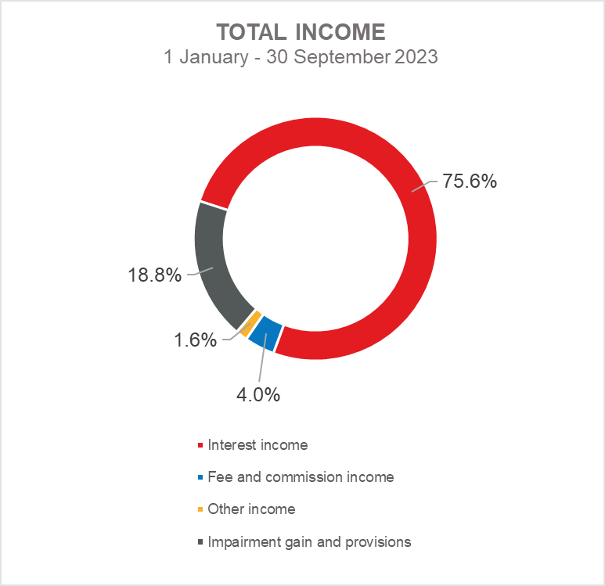 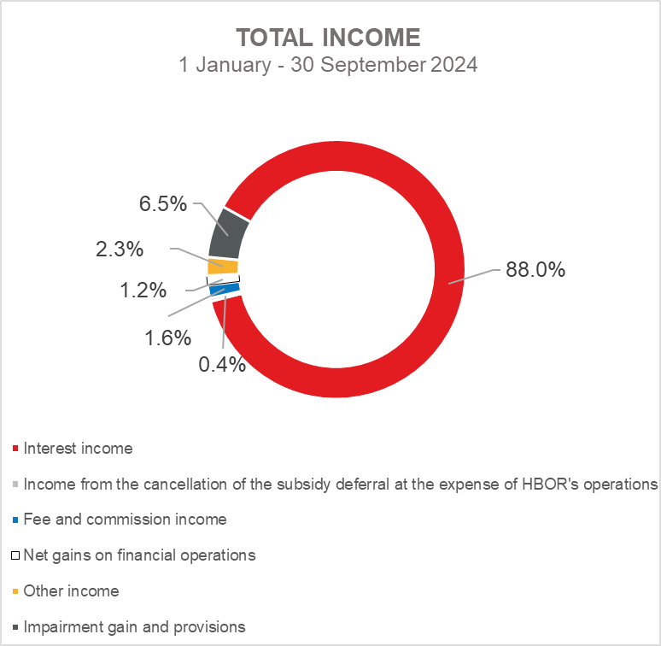

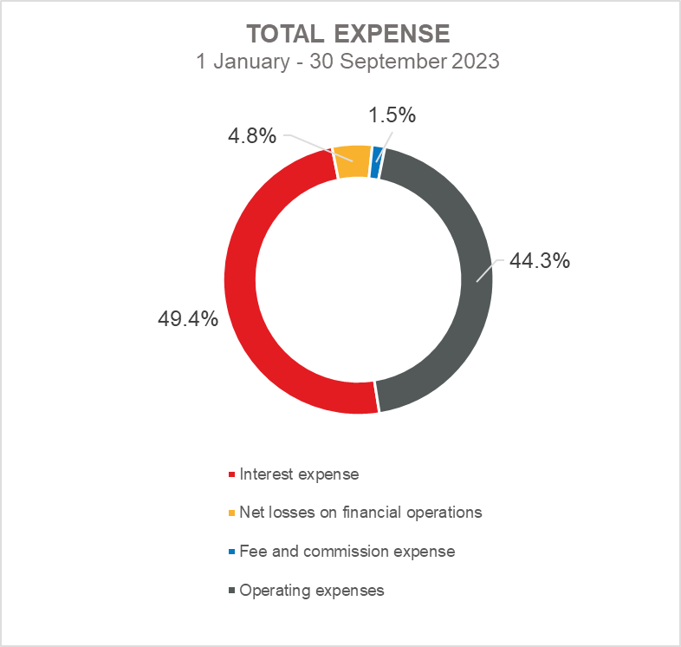 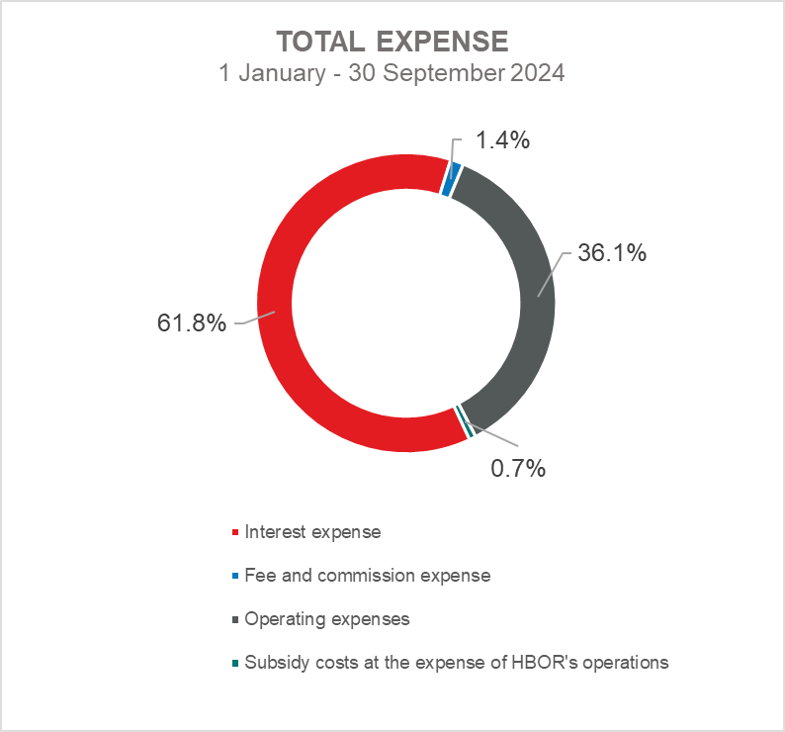

***Net interest income***

Net interest income amounted to EUR 53.5 million, an increase of 10.3 percent on the same period of the previous year.

Interest income stood at EUR 87.8 million, an increase of 28.9 percent compared with the same reporting period previous year due to an increase in interest income from lending activity in the amount of EUR 12.0 million, the collection of subsidised interest income in the amount of EUR 3.4 million and due to an increase in interest income from short-term Treasury operations in the amount of EUR 3.8 million.

In addition, interest income rose by EUR 0.4 million owing to the income resulting from the cancellation of the subsidy deferral at the expense of HBOR's operations.

Interest expenses amounted to EUR 34.7 million, an increase of 77.0 percent on the same reporting period last year, which is the result of growth of borrowings and interest rates.

Considering the described trends, the higher increase in interest income in the absolute amount of EUR 19.7 million compared with interest expenses of EUR 15.1 million influenced the increase in the net interest margin in comparison with the same reporting period previous year, which stood at 1.8 percent, whereas it had amounted to 1.7 percent in the same period previous year.

***Net fee income and commission income***

Net fee and commission income amounted to EUR 0.8 million, a decrease of 73.3 percent compared with the same reporting period last year due to a decrease in income from fees and commissions for transactions in the name and for the account and in respect of the fees for issued guarantees.

***Net gains/(losses) on financial operations***

Net gains/(losses) on financial operations are comprised of net foreign exchange gains/(losses) on the principal amount of receivables and liabilities, gains/(losses) arising out of value adjustment of financial assets stated at fair value through profit or loss and realised gains/(losses) arising out of financial assets at fair value through other comprehensive income.

In the reporting period, net gains from financial activities amounted to EUR 1.2 million, whereas, in the same reporting period previous year, net losses amounted to EUR 1.9 million.

.

A breakdown of changes in the exchange rate of the euros against the USD:

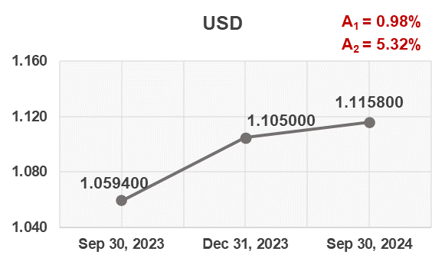

Note:

A1 = EUR appreciation Sep 30, 2024/Dec 31, 2023

A2 = EUR appreciation Sep 30, 2024/Sep 30, 2023

Funds and sources of funds that are denominated in another currency or are indexed to the currency clause are converted by HBOR into the equivalent value in EUR at the middle exchange rate of HBOR or another agreed exchange rate on the reporting date.

Revenues and expenditures in another currency are converted at the exchange rate on the transaction date. The resulting foreign exchange gains or losses are recorded in the Profit or Loss Account in net figures.

***Operating expenses***

Operating expenses that include general and administrative expenses and other operating expenses stood at EUR 20.3 million, an increase of 15.3 percent compared with the same reporting period last year, as a result of an increase in general and administrative expenses due to an increase in the number of employees.

On 30 September 2024, HBOR had 436 employees (on 30 September 2023: 409 employees).

***Subsidy costs at the expense of HBOR's operations***

Subsidy costs at the expense of HBOR's operations stood at EUR 0.4 million and are linked with the new product of subsidising interest rates at the expense of HBOR's operations that was introduced in the second half of 2023.

***Impairment gain/(loss) and provisions***

In the reporting period, a net gain from impairment of placements in the amount of EUR 6.5 million was recorded (in the period 1 January – 30 September 2023: net gain in the amount of EUR 17.0 million).

The text to follow contains a breakdown of portfolio quality:

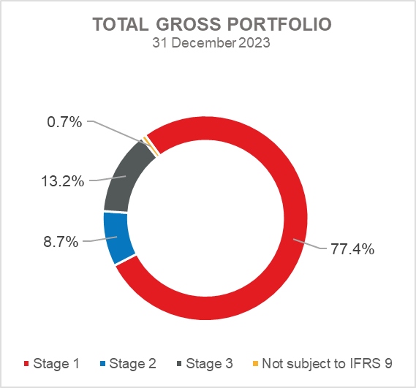 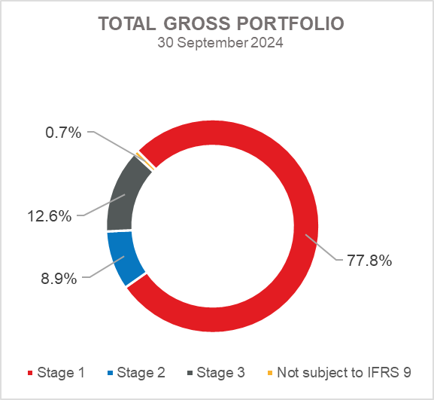

**Overview of total gross portfolio and provisions by structure – financial institutions and direct**

|  |  |  |  |  |
| --- | --- | --- | --- | --- |
|  | **2023** | | **Sep 30, 2024** | |
|  | **In millions of euros** | **Breakdown**  **(percent)** | **In millions of euros** | **Breakdown**  **(percent)** |
| **Total gross portfolio** | **4,980.5** | **100.0** | **4,975.1** | **100.0** |
| **Of which:** |  |  |  |  |
| **- financial institutions** | 1,576.6 | 31.7 | 1,561.7 | 31.4 |
| **- direct** | 3,403.9 | 68.3 | 3,413.4 | 68.6 |
| **Total provisions** | **496.9** | **100.0** | **483.6** | **100.0** |
| **Of which:** |  |  |  |  |
| **- financial institutions** | 7.9 | 1.6 | 6.8 | 1.4 |
| **- direct** | 489.0 | 98.4 | 476.8 | 98.6 |
| **Provisions/gross portfolio** | **10.0 percent** | **-** | **9.7 percent** | **-** |

.

**Significant changes in financial position**

Total assets of HBOR as at 30 September 2024 amounted to EUR 4,017.7 million and were retained at the level from the beginning of the year.

***Cash on hand and deposits with other banks***

As at 30 September 2024, cash on hand and deposits with other banks amounted to EUR 154.7 million representing 3.9 percent of total assets, an increase of 39.4 percent compared with 31 December 2023 as a result of reallocation of liquidity reserve funds.

***Loans to financial institutions and other customers***

As at 30 September 2024, total net loans amounted to EUR 3,528.7 million representing 87.8 percent of total assets, a decrease of 2.0 percent on the beginning of the year.

Total gross loans amounted to EUR 3,999.0 million, a decrease of 1.9 percent compared with 31 December 2023. Gross loans to other customers were retained at the level from the beginning of the year. Gross loans to financial institutions decreased by 6.5 percent compared with the end of 2023 due to the decrease in short-term placements.

As at 30 September 2024, the proportion between gross loans on-lent through financial institutions and direct placements stood at 29 percent : 71 percent (31 December 2023: 31 percent : 69 percent).

***Financial assets at fair value through profit or loss***

Loans at fair value (HBOR has determined that mezzanine loans are classified here), investments in investment funds and a part of equity instruments are classified to these assets. As at 30 September 2024, the total amount of these assets was EUR 66.0 million representing 1.6 percent of total assets.

***Financial assets at fair value through other comprehensive income***

***a) Debt instruments***

Bonds of the Republic of Croatia and treasury bills of the Ministry of Finance as part of liquidity reserve as well as bonds of a company are classified to these assets. On the reporting date, they amounted to EUR 238.7 million, representing 5.9 percent of total assets and recorded an increase compared to the beginning of the year by 8.0 percent.

The impairment of these financial assets is calculated through the application of the model of expected credit losses in the manner that provisions are recognised in the accounts of other comprehensive income, thus not reducing the carrying amount of these financial assets in the statement on financial position. On the reporting date, they amounted to EUR 0.4 million in other reserves.

***b) Equity instruments***

Equity instruments (shares of companies) that HBOR does not intend to sell and to which irrevocable option of subsequent measurement of fair value through other comprehensive income without recycling is applied are classified to these assets, i.e. reserves recognised under other comprehensive income will never be transferred to the statement of profit or loss.

On the reporting date, these assets amounted to EUR 8.1 million, representing 0.2 percent of total assets.

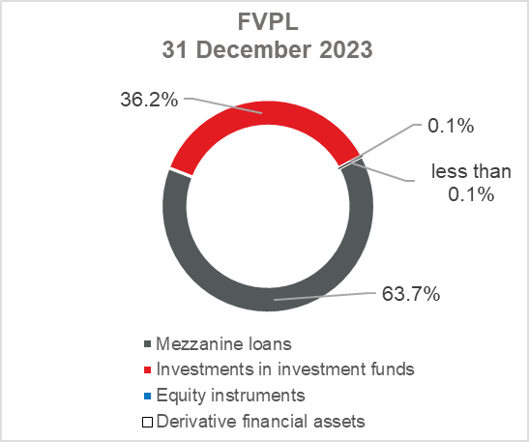 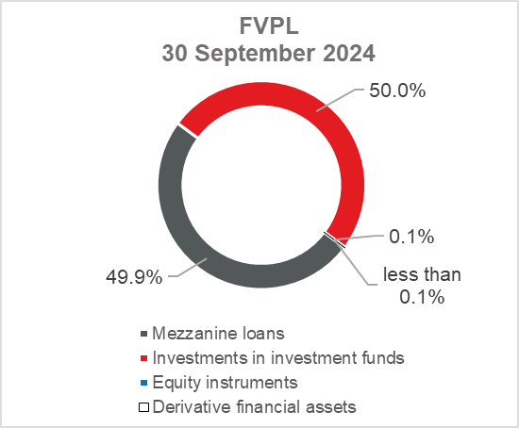

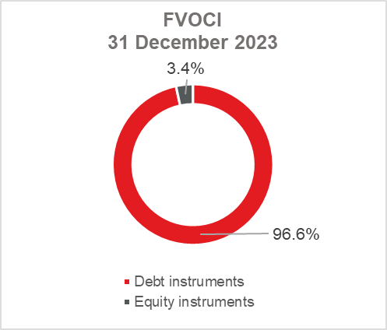 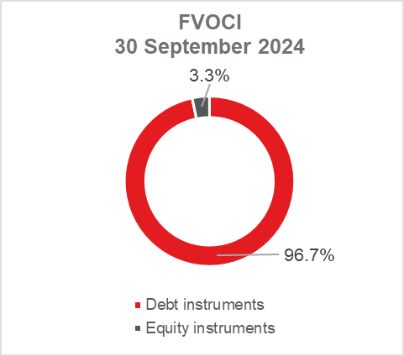

***Total liabilities***

As at 30 September 2024, total liabilities amounted to EUR 2,513.9 million, which represents 62.6 percent of total liabilities and total equity. The major part of total liabilities consists of HBOR’s borrowings in the total amount of EUR 2,195.9 million.

Borrowings decreased by 2.5 percent compared with the beginning of the year, whereas changes in these liabilities are shown in the following table:

|  |  |
| --- | --- |
|  | (in millions of euros) |
| - Draw-down of funds borrowed under previously contracted  funds of special financial institutions | 457.2 |
| - Repayments of borrowings | (514.7) |
| - Foreign exchange gains or losses | (0.1) |
| - Other calculations * | 2.3 |
| **Total changes** | **(55.3)** |
|  |  |
| *\* Other calculations relate to changes in amount of interest not due and deferred fees.* | |

***Total equity***

Out of the total amount of total liabilities and total equity, EUR 1,503.8 million or 37.4 percent relate to total equity.

Total equity of HBOR is comprised of the capital and the guarantee fund. HBOR’s capital is comprised of founder’s capital contributed from the budget of the Republic of Croatia, retained earnings from the profits generated in the previous years, other reserves and profits for the current period.

The total amount of capital contributed from the budget of the Republic of Croatia stood at EUR 902.3 million, and the remaining amount to be contributed to the founder’s capital up to the total amount of EUR 929.1 million set by the HBOR Act is EUR 26.8 million.

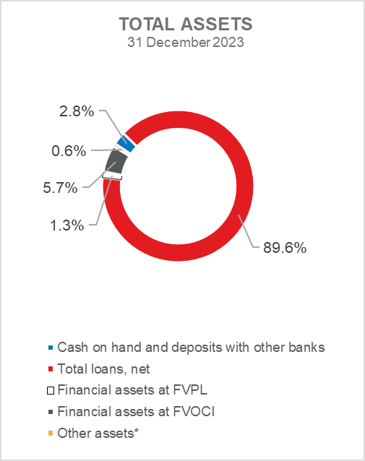 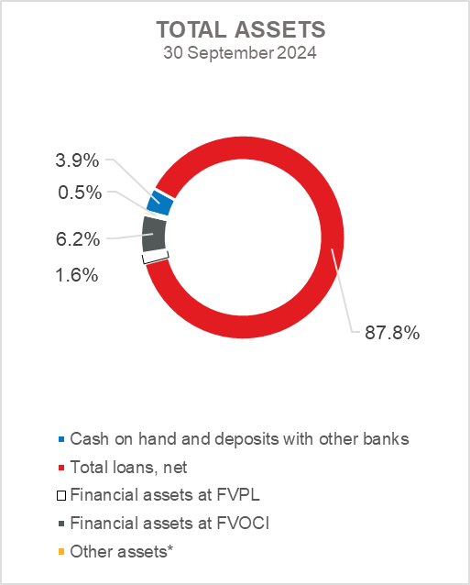

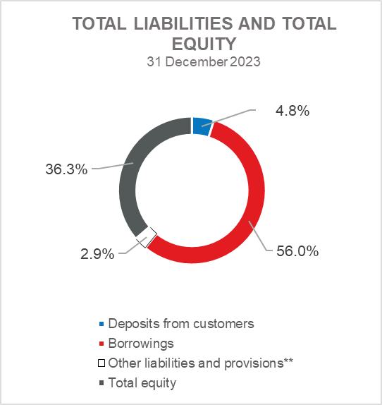 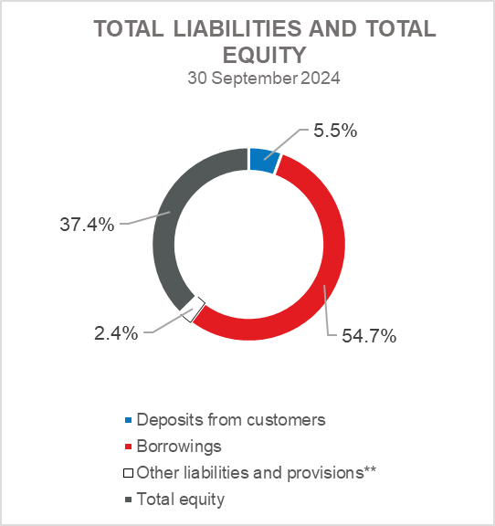

*Investments in subsidiaries, Property, plant and equipment and intangible assets, Foreclosed assets and Other assets.

** Provisioning includes provisioning for guarantees, commitments and other liabilities.